INFOPOLISH: An Advanced Data Sanitization
Geyasri Vagdevi
Master’s in Information Technology
The University of Waikato
gm429@students.waikato.ac.nz
Soundirya Murugan
Master’s in Information Technology
The University of Waikato
Sm2183@students.waikato.ac.nz
Joe Newman Jaya Thomas
Master’s in Cyber Security
The University of Waikato
jj494@students.waikato.ac.nz
Sreeja Ajithkumar
Master’s in Cyber Security
The University of Waikato
sa2238@students.waikato.ac.nz
Rahul Chakali
Master’s in Cyber Security
The University of Waikato
rc487@students.waikato.ac.nz
Venkatasubramanian Sankaranarayanan
Master’s in Cyber Security
The University of Waikato
vs290@students.waikato.ac.nz

Abstract— From the past few years, Tech companies are having a vast amount of growth in digital data. Some adjustments are being made to cope up with the inflow of overwhelming amounts of data into MNCs. As a result, it is necessary to evaluate this data in order to extract some relevant information and design an algorithm based on this study. Data mining and machine learning are the rapidly increasing technologies for handling such huge data. Thus, technologies are being used by practically all firms in the field. Companies spend a lot of time on preparing the data (cleaning, visualization, imputation, normalization) rather than training the model, it also takes a huge number of code lines to be executed. The project's goal is to create an easy-to-use platform for cutting down data preparation time. The end result of this project is a refined and unambiguous processed dataset that can be utilized for further development. Most significantly, it saves developers time and effort because the task of data pre-processing is totally handled by our software.
Keywords— Web application; Pre-processing; Machine Learning; datamining; Flask
INTRODUCTION
The exponential growth of data caused existing data models to adapt or update to new data structure alterations in information systems. In these long-established databases, data is often kept in relational models. As the amount of data has expanded, businesses have been using both structured and unstructured data as part of their information systems. Machine Learning is an area of artificial intelligence that provides the ability to learn and grow from experience without the need to set up any rules or actively design systems. However, before we can model the data, conduct a few actions on it to discover the hidden characteristics that play a key role. Many organizations invest a significant amount of time determining the features and presenting the facts in a far more relevant fashion but what if we can automate it?
Yes, the project is capable of accomplishing this via automating data cleansing and pre-processing. As a result, many firms might save time on requirements of the machine learning process. To construct interactive web applications, we used to develop web pages, on the frontend, and several machine learning algorithms and data-preprocessing techniques on the backend. Flask, a framework, was useful for tying together the backend and frontend. Our strategy for speeding up and automating data preparation is presented in this paper.
LITERATURE SURVEY
Before starting this project, it was very important to understand the process of machine learning. It was also crucial to find out if there were any pre-existed websites, during this search we found some astonishing research papers which gave us the foundation to build this project. In [1] xu Chu and Ihab F. IIyas mentioned that finding and taking care of dirty data is a never-ending problem, which can be solved utilizing machine learning to boost the effectiveness and accuracy of data cleaning, as well as taking into account the implications of data cleaning on statistical analysis. From this paper we can understand that data cleaning will kill time and require human power. We may have found a solution in this project. [2] Erhard Rahm and Hong Hai Do have discussed some of the current tools which support data cleaning. This paper has helped us to deal with such data. [3] Carter, B. (2014), who wrote this research paper completely, focuses on how students can use applications like HTML, CSS, Java Script and SQLite to create some distinctive web applications for numerous purposes. [4] paper written by Marshall, I.J and Wallace assisted us to understand, automation of machine learning which is ready to use, by stating strengths and weakness of automating ML. [5] Lokhande, Aslam, Fankar and his team authored the benefits of flask and its importance, this paper specifies the fact that good appearance will play a non-trivial role in user experience. [6] Grinberg M, had published a book, in which it describes how to use the flask framework for web development and connecting backend and frontend. [8] Maxim Chernyshev and his team authored the book in Cloud-Native Application Security, this paper involves the security risks, opportunities, and challenges in securing the evolving attack from cloud computing services. [9] Paper written by Varia,J and Mathew, S., assisted us to understand the overview of amazon web services.
PROPOSED SYSTEM
In our approach, the web application of machine learning would provide solutions to some of the challenges faced by companies, the 2 main challenges are time consumed during the process of preparing the data and finding the skilled programming labour to work on data. In our project we provided a 7-step approach which consists of pre-processing techniques followed by machine learning algorithms and deep learning algorithms. The proposed 7 steps process is done with help of user -friendly interface i.e., Graphical user interface.
The 7 steps approach is:
A. GATHERING DATA
The first phase in our project is data collection, Client with a dataset will be able to upload to the web site of the project. This step is achieved by the package called “Pandas”. The amount and quality of the data collected impact the output’s efficiency. The more data there is, the more precise the forecast. But as per our project the data will be given by the user in file format such as .csv or .xlsx. In this step the client is given freedom to gather as much data as possible.
B. OPERATION ON DATA
Data exploration: Initial step in data analysis, exploring and visualizing the data to find insights of datasets, provides patterns or indicates regions for which further investigation is required.
Data pre-processing: One of most important steps in our project as this step converts the raw data into a comprehensible pattern which is understandable by machine. This step is important because of 3 reasons,
- For improving the accuracy.
- To understand the data in a better way.
- For updating the data in sequential order with respect to time.
C. DATA IMPUTATION
Although the data from the previous stage has been cleansed, there are certain difficulties since it is maintained by humans, which might reduce the model’s accuracy. In this stage we deal with missing data, categorical data etc.… We employ a variety of techniques which can be used by the client as per his/her requirements, Technologies including One Hot encoding, Label Encoder, mode filling, KNN imputer, and others.
D. FEATURE ENGINEERING
Feature engineering is a fundamental stage in machine learning. The process of creating fake characteristics or fake qualities to improve performance of Machine learning models. This phase is most likely to be used when the client decides to use a predictive model in the next step using feature engineering. The client can easily find the perfect predictor variable from the data dataset.
E. MODEL SELECTION
As we near the end of the execution, we provide the user the option to select which machine learning or deep learning algorithm of his/her choice to perform on the preprocessed dataset. Just before the select of model user has an option to choose his desired hyperparameters.Models provided in our project are classified into two types
- Machine learning Model
- Linear Regression
- Logistic Regression
- KNN regressor
- KNN classifier
- SVM
- Random forests
- Random forests
- Decision trees.
- Deep Learning Model
- Simple Ann
- Keras Tuner
F. GRAPHICAL REPRESENTATION
This is the nearly final phase, in which the accuracy score and model performance are shown in the form of a graphical interface that is easily legible and intelligible. Based on the graph, the user can repeat the process till he is pleased with the result of performance. Python packages matplotlib and seaborn are used to create graphical representations. Various graphical structures, such as line graphs, histograms, box plots, scatter plots, and so on, can be implemented.
G. PICKLE FILE EXTRACTION
Pickle is a handy Python utility that lets you preserve your models, reduce retraining time, and distribute, commit, and re-load pre-trained machine learning models. It's most typically linked with storing and reloading learned machine learning models, although it may be used for any object. In our project final level pickle file is reduced which consists of metadata of the trained model, which can be used by the user, if he wants to store them for future references. These pickle files are used against new input for validation and prediction.
TOOLS AND TECHNOLOGIES

- Tools
- HTML, CSS
- PHP
- Flask using Python
- Numpy and Pandas
- Sklearn
- AWS-S3
- AWS-Elastic Load Balancer
- AWS-IAM
- AWS-SQS
- AWS-SNS
- AWS-Security groups
- AWS-DynamoDB
- AWS-Cloud Watch
- Technologies
- Front-End Development
- Back-End Development
- Machine Learning
- Deep Learning
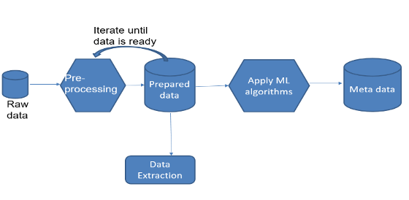

Fig.1 Block diagram of system architecture
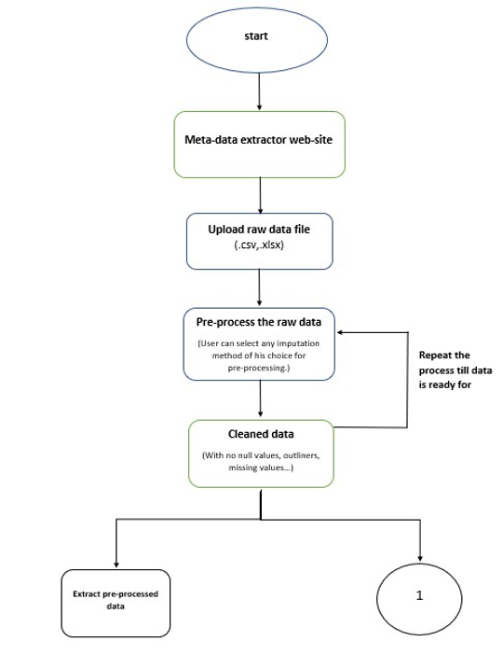

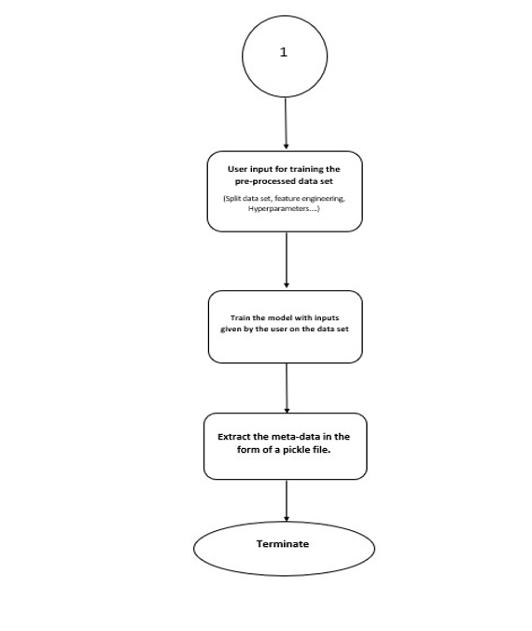
Fig.2 Workflow of the project (7 steps)

SECURITY IMPLEMENTATION
According to OWASP Top 10 guidelines, we have implemented several layers of security for protecting user's data in various levels. We have implemented 3 layers of security to ensure the user's data is secure at most. First layer of security includes "input validation" and "String sanitization" which prevents injection attacks, cryptographic failures, Security misconfiguration, Data integrity issues and also Server-Side Request Forgery.
We have also implemented various "error handling" techniques for avoiding most common error that could possibly occur during login and sign-up of user. We leverage AWS SDK, which allows safe retrieval and appending of queries in the database, ensuring that sensitive information remains protected. Additionally, we have enforced IAM roles that which ensures the connection is live and secure every hour. A set of roles and policies which allows EC2 to access S3, DynamoDB, SQS and SNS services has been implemented.
This minimizes potentially unauthorized access to the cloud resources. For monitoring all the services which runs over cloud, we have implemented CloudWatch system which gives insights and real time monitoring. Overall, Penetration testing is also done which involved "Whitebox" testing. An crawler detection system is also installed with the tag "robots.txt" which decides which sites to be accessed and not to be. This also helps in search engine optimization of the website "if" hosted.
DATASETS
We have utilized publicly available datasets from Kaggle to train and evaluate our machine learning models. Kaggle provides a rich source of structured and unstructured data, which is essential for training robust predictive models. These datasets were integrated into our application to demonstrate real-world data handling, cleaning, and processing techniques. By using Kaggle datasets, we ensured that our model training process was both realistic and scalable, which is critical for developing solutions that can handle diverse data sources.
In conjunction with AWS services, the datasets were securely accessed, processed, and stored, adhering to strict security protocols. This approach allowed us to validate the model performance on multiple datasets while ensuring data integrity and security throughout the process
SERVICES USED
In our project, we incorporated various AWS and open-source services to enhance both functionality and security. We utilized Open-Source Datasets from Kaggle to train our machine learning models, enabling realistic data-driven solutions. The DynamoDB service was used to store and manage non-relational data efficiently, ensuring scalability and low-latency access. To handle computational tasks, we employed EC2 (Elastic Compute Cloud) instances, which provided the flexibility and computing power needed for model training and data processing.
For load distribution, an Elastic Load Balancer was implemented to evenly distribute traffic across multiple EC2 instances, enhancing the system's reliability. CloudWatch was used for monitoring and managing operational insights, ensuring real-time detection of performance anomalies. We utilized IAM (Identity and Access Management) to enforce role-based access control, refreshing session tokens every hour to prevent unauthorized access.
Additionally, SQS (Simple Queue Service) and SNS (Simple Notification Service) were integrated to manage asynchronous communication and messaging between components, ensuring seamless data flow. Security Groups were configured to define inbound and outbound traffic rules, providing an essential layer of network security for our EC2 instances and other AWS resources.
AWS EXPENDITURE REPORT
As part of our project, we have utilized various AWS services to ensure scalability, security, and performance. The total expenditure on AWS services as of now amounts to $7.63. Below is a breakdown of the services used and their contribution to the overall cost:
- EC2 (Elastic Compute Cloud): Used for hosting and running our machine learning models, EC2 instances provided flexible computing power. The cost primarily reflects the on-demand instance hours utilized during model training and data processing.
- DynamoDB: This service was used to store and retrieve non-relational data efficiently. The cost incurred is related to read/write capacity units and storage used for managing datasets.
- Elastic Load Balancer: This service distributed incoming traffic across multiple EC2 instances, ensuring reliability and fault tolerance. The cost reflects the load balancer’s usage in managing requests during peak times.
- CloudWatch: CloudWatch provided real-time monitoring of the system, generating operational insights and security alerts. The cost includes metrics collection, custom dashboards, and alarms triggered during the project.
- IAM (Identity and Access Management): While IAM is a free service, there is a minor associated cost for advanced security features and detailed logging of user activities.
- SQS (Simple Queue Service) and SNS (Simple Notification Service): These services facilitated communication between different components of the application, ensuring reliable messaging and notifications. The cost is based on the number of requests and data processed.
- Security Groups: The use of security groups for controlling inbound and outbound traffic was essential to ensure the protection of EC2 instances. This service is included in the overall cost as part of managing network traffic securely.
Overall, the expenditure of $7.63 reflects the efficient use of AWS resources to maintain a secure, scalable, and high-performing application environment.

MOTIVATION
Ever since we started acquiring knowledge about machine learning, we found it fascinating but we also found that some other people who were able to understand the theoretical process but felt difficult to apply practically. Furthermore, every company with a unique data set has more time on preprocessing the dataset and coding the ML algorithms which have already been used. Hence, we wanted to provide a platform, a solution for above-mentioned problems, where users with basic knowledge on ML can implement Data science and Machine learning. We would also like to implement few more advanced Security features and customizations on ease of access for our application.
CONCLUSION
In conclusion, this project is a great platform, a one stop solution, for all types of machine learning algorithms. Any consumer, who is ambiguous to choose a perfect algorithm that is best suited for the data, usually costs more time and energy. The process, from researching algorithms to acquiring accuracy, requires skilled labor and a huge amount of investment. If the accuracy didn’t reach the expectation, then the process is looped until the desired accuracy is obtained. Our main idea, or the goal of the project can be a solution. Simply it can be expressed as “Everything in one hand”.
REFERENCES
[1] Chu, X., IIyas , I.F., Krishnan, S. and Wang, J.,2016, June. Data cleaning: Overview and emerging challenges. In Proceedings of the 2016 international conference on management of data (pp. 2201-2206).
[2] Rahm, E. and Do, H.H., 2000. Data cleaning: Problems and current approaches. IEEE Data Eng.Bull., 23(4), pp.3-13.
[3] Chou, Y.C. and Liao, H.C., 2014, August. A Web Page data Hiding Method by Using Tag and CSS Attribute Setting. In 2014 Tenth International Conference on Intelligent Information Hiding and Multimedia Signal Processing (pp. 122-125). IEEE
[4] Marshall, I.J. and Wallace, B.C., 2019. Toward systematic review automation: a practical guide to using machine learning tools in research synthesis. Systematic reviews, 8(1), pp.1-10.
[5] Lokhande, P.S., Aslam, F., Hawa, N., Munir, J. and Gulamgaus, M., 2015. Efficient way of web development using python and flask.
[6] Grinberg, M., 2018. Flask web development: developing web applications with python. “O’Reilly Media, Inc.”.
[7] Jansen, W., & Grance, T. (2011). NIST Special Publication 800-144: Guidelines on Security and Privacy in Public Cloud Computing. National Institute of Standards and Technology.

[8] Maxim Chernyshev, Zubair Baig, and Sherali Zeadally. 2021. Cloud-Native Application Security: Risks, Opportunities, and Challenges in Securing the Evolving Attack Surface. Computer 54, 11 (Nov. 2021), 47–57. https://doi.org/10.1109/MC.2021.3076537

[9] Varia, J., Matthew, S., Overview of Amazon Web Services. https://media.amazonwebservices.com/AWS_Overview.pdf. Accessed 13 July 2020.

[10] Diagboya, E. (2021). Infrastructure Monitoring with Amazon CloudWatch: Effectively monitor your AWS. infrastructure to optimize resource allocation, detect anomalies, and set automated actions. Packt Publishing Ltd.

Minutes of Meetings
Meetings were conducted on every Sundays 10.15 am - 5:15 pm
Location: Students Library
Date: 28/07/2024
Attendees: Geyasri Vagdevi, Joe Newman Jaya Thomas, Rahul Chakali, Soundirya Murugan, Sreeja Ajithkumar, Venkatasubramanian Sankaranarayanan
Agenda Items:
Ø Finalizing the topic of the group project.
Ø Fixing the time of project proposal meetings.
Ø Discussed about the overview of the project.
Ø Need to send a project proposal for approval.

Action Items | Owner | Deadline | Status
Finalized the project and submit project proposal | Sreeja Ajithkumar  Geyasri Vagdevi  Rahul Chakali  Venkatasubramanian Sankaranarayanan  Joe Newman Jaya Thomas  Soundirya Murugan | 03/08/2024 | In Progress
Date: 04/08/2024
Attendees: Geyasri Vagdevi, Joe Newman Jaya Thomas, Rahul Chakali, Soundirya Murugan, Sreeja Ajithkumar, Venkatasubramanian Sankaranarayanan
Agenda Items:
Ø Submitted our short proposal of our project.
Ø Got approval from the lecturer
Ø Discussed about the work load and divided work to team members.
Ø Services to be used on this project.
Ø Discussed about the services and its functions which are going to be used in the project.
Ø Q/A session regarding previous week
Action Items | Owner | Deadline | Status
Finalized the project and submit project proposal | Sreeja Ajithkumar  Geyasri Vagdevi  Rahul Chakali  Venkatasubramanian Sankaranarayanan  Joe Newman Jaya Thomas  Soundirya Murugan | 10/08/2024 | Completed
Discussed about Work load and dividing the task | Sreeja Ajithkumar  Geyasri Vagdevi  Rahul Chakali  Venkatasubramanian Sankaranarayanan  Joe Newman Jaya Thomas  Soundirya Murugan | 10/08/2024 | In Progress
Date: 11/08/2024
Attendees: Geyasri Vagdevi, Joe Newman Jaya Thomas, Rahul Chakali, Soundirya Murugan, Sreeja Ajithkumar, Venkatasubramanian Sankaranarayanan
Agenda Items:
Ø Discussed about the work load and divided work/task to team members.
Ø Planning for proper tracking of VCS (GitHub).
Ø Before starting a development trying to do Figma Prototype.
Ø Planning to start the development – (Front-End).
Ø Planned to provide access to Private repository to all members this week.
Ø Discussed about the frontend and its integration with backend.
Ø Discussed about the individual contribution for the group project.
Ø Q/A session regarding previous week.

Action Items | Owner | Deadline | Status
Discussed about Work load and dividing the task | Sreeja Ajithkumar  Geyasri Vagdevi  Rahul Chakali  Venkatasubramanian Sankaranarayanan  Joe Newman Jaya Thomas  Soundirya Murugan | 17/08/2024 | Completed
Creating repository to all team members | Sreeja Ajithkumar  Geyasri Vagdevi  Rahul Chakali  Venkatasubramanian Sankaranarayanan  Joe Newman Jaya Thomas  Soundirya Murugan | 17/08/2024 | In Progress
Planning to start - Front End | Sreeja Ajithkumar  Geyasri Vagdevi | 17/08/2024 | In Progress
Planning to start -Backend End | Rahul Chakali  Venkatasubramanian Sankaranarayanan | 17/08/2024 | Yet to Start
Planning to start - Reporting | Joe Newman Jaya Thomas  Soundirya Murugan | 17/08/2024 | Yet to Start
Date: 18/08/2024
Attendees: Geyasri Vagdevi, Joe Newman Jaya Thomas, Rahul Chakali, Soundirya Murugan, Sreeja Ajithkumar, Venkatasubramanian Sankaranarayanan
Agenda Items:
Ø Discussed about the frontend and its integration with backend
Ø Created AWS public repository on GitHub Project.
Ø Completed the Figma Prototype.
Ø Services to be used on this project.
Ø Initially started analysis of what algorithms and services and resources can be used in the project.
Ø Started Frontend, Backend, Reporting.
Ø Q/A session regarding previous week
Action Items | Owner | Deadline | Status
Creating repository to all team members | Sreeja Ajithkumar  Geyasri Vagdevi  Rahul Chakali  Venkatasubramanian Sankaranarayanan  Joe Newman Jaya Thomas  Soundirya Murugan | 24/08/2024 | Completed
Started - Front End | Sreeja Ajithkumar  Geyasri Vagdevi | 24/08/2024 | In Progress
Started – Back End | Rahul Chakali  Venkatasubramanian Sankaranarayanan | 24/08/2024 | In Progress
Started - Reporting | Joe Newman Jaya Thomas  Soundirya Murugan | 24/08/2024 | In Progress
Date: 25/08/2024
Attendees: Geyasri Vagdevi, Joe Newman Jaya Thomas, Rahul Chakali, Soundirya Murugan, Sreeja Ajithkumar, Venkatasubramanian Sankaranarayanan
Agenda Items:
Ø Discussed Chosen a name of the project.
Ø Challenges faced in front end ,backend and integration.
Ø Creating the report as per the IEE E standards.
Ø Trying to assign Roles for each member.
Ø Discussed about the aws expenditure.
Ø Discussed about the datasets.
Ø Q/A session regarding previous week

Action Items | Owner | Deadline | Status
Front End | Sreeja Ajithkumar  Geyasri Vagdevi | 31/08/2024 | In Progress
Back End | Rahul Chakali  Venkatasubramanian Sankaranarayanan | 31/08/2024 | In Progress
Reporting | Joe Newman Jaya Thomas  Soundirya Murugan | 31/08/2024 | In Progress
Date: 01/09/2024
Attendees: Geyasri Vagdevi, Joe Newman Jaya Thomas, Rahul Chakali, Soundirya Murugan, Sreeja Ajithkumar, Venkatasubramanian Sankaranarayanan
Agenda Items:
Ø Discussed about security implementations.
Ø Discussed about the AWS expenditure till date.
Ø Challenges faced in our project
Ø Q/A session regarding previous week

Action Items | Owner | Deadline | Status
Front End | Sreeja Ajithkumar  Geyasri Vagdevi | 07/09/2024 | In Progress
Back End | Rahul Chakali  Venkatasubramanian Sankaranarayanan | 07/09/2024 | In Progress
Reporting, Testing and Security Implementation | Joe Newman Jaya Thomas  Soundirya Murugan | 07/09/2024 | In Progress
Date: 08/09/2024
Attendees: Geyasri Vagdevi, Joe Newman Jaya Thomas, Rahul Chakali, Soundirya Murugan, Sreeja Ajithkumar, Venkatasubramanian Sankaranarayanan
Agenda Items:
Ø Discussed about security implementations.
Ø Discussed about the AWS expenditure till date.
Ø Challenges faced in our project.
Ø Completed testing.
Ø Q/A session regarding previous week

Action Items | Owner | Deadline | Status
Front End | Sreeja Ajithkumar  Geyasri Vagdevi | 15/09/2024 | Completed
Back End | Rahul Chakali  Venkatasubramanian Sankaranarayanan | 15/09/2024 | Completed
Reporting and Testing | Joe Newman Jaya Thomas  Soundirya Murugan | 15/09/2024 | Completed

